Specifications

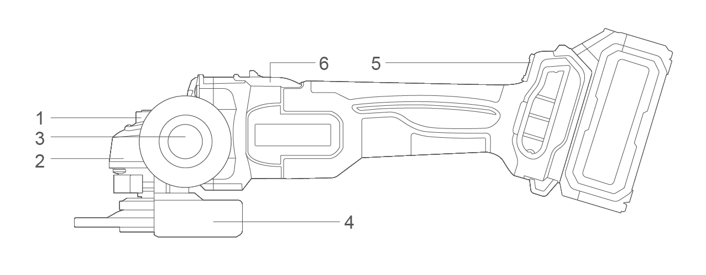

Components

|  |  |
| --- | --- |
| 1. Spindle locking button 2. Aluminum gear box 3. Auxiliary handle | 1. Disc guard 2. Speed adjustment 3. On/Off switch button |

Accessories

1. Auxiliary handle 1pcs
2. Spanner 1pcs

Technical specifications

|  |  |  |  |
| --- | --- | --- | --- |
| Model No. | CAGLI27103  CAGLI27103xy | CAGLI27153  CAGLI27153xy | UCAGLI27153  UCAGLI27153xy |
| **Voltage** | 20V | | |
| **No-load speed** | 3000/6000/9000/min | | |
| **Disc diameter** | 100mm | 115mm | 4-1/2'' |
| **Spindle thread** | M10 | M14 | 5/8˝-11UNC |

**Model No. NOTE: x** (blank, 1,2,3,4,5,6,7,8,9,E,S,A,M); **y** (blank, -1,-2,-3,-4,-5,-6,-7,-8,-9,E,S,A,M)

* Due to our continuing program of research and development, the specifications herein are subject to change without notice.
* Specifications and battery cartridge may differ from country to country.

**Noise/Vibration information**

The noise emission, measured in accordance with EN62841-2-3:

|  |  |  |
| --- | --- | --- |
| Sound pressure level | LpA | 90.0 dB (A) |
| Sound power level | LwA | 98.0 dB (A) |
| Uncertainty | K | 3 dB (A) |

**Wear hearing protection!**

The vibration total value and its uncertainty determined according to EN62841-2-3:

**Surface grinding:**

|  |  |  |
| --- | --- | --- |
| Vibration emission value | ah,SG | 4.6 m/s2 |
| Uncertainty | K | 1.5 m/s2 |

**Concrete grinding and cutting off:**

|  |  |  |
| --- | --- | --- |
| Vibration emission value | ah,DS | 4.7m/s2 |
| Uncertainty | K | 1.5 m/s2 |

**NOTE:** For other applications, e.g., abrasive cutting-off operations or wire brushing other vibration values could occur.

That the declared vibration total value has been measured in accordance with a standard test method and may be used for comparing one tool with another.

That the declared vibration total value may also be used in a preliminary assessment of exposure.

**⚠ WARNING!**

* **That the vibration emission during actual use of the power tool can differ from the declared total value depending on the ways in which the tool is used;**
* **Identify safety measures to protect the operator that are based on an estimation of exposure in the actual conditions of use (taking account of all parts of the operating cycle such as the times when the tool is switched off and when it is running idle in addition to the trigger time).**

**⚠ WARNING!**

**Only use original battery pack and battery charger as below for this power tool:**

|  |  |  |  |
| --- | --- | --- | --- |
| Product | Battery pack | | |
| Model No. | Type | Rated voltage | Rated capacity |
| FBLI2001  FBLI2001xy | Lithium-Ion | 18.5V d.c., 20V Max | 2.0Ah |
| FBLI2002  FBLI2002xy | 4.0Ah |
| FBLI2003  FBLI2003xy | 5.0Ah |

**Model No. NOTE:** x (blank, 1,2,3,4,5,6,7,8,9,E,S,A,M); y (blank, -1,-2,-3,-4,-5,-6,-7,-8,-9,E,S,A,M)

|  |  |  |  |  |
| --- | --- | --- | --- | --- |
| Product | Battery pack charger | | | |
| Model No. | Input power | Input voltage | Output rated voltage | Output rated current |
| FCLI2001  FCLI2001xy | 50W | 220-240V  ~50/60Hz | 20V d.c. | 2A |
| UFCLI2001  UFCLI2001xy | 110-120V  ~50/60Hz |
| FCLI20411  FCLI20411xy  FCLI2034  FCLI2034xy | 105W | 220-240V  ~50/60Hz | 21V d.c. | 4A |
| UFCLI20411  UFCLI20411xy  UFCLI2034  UFCLI2034xy | 110-120V  ~50/60Hz |
| FCLI2001-9 | 50W | 100-240V  ~50/60Hz | 20V d.c. | 2A |
| FCLI20411-9  FCLI2034-9 | 105W | 100-240V  ~50/60Hz | 21V d.c. | 4A |

**Model No. NOTE:** x (blank, 1,2,3,4,5,6,7,8,9,E,S,A,M); y (blank, -1,-2,-3,-4,-5,-6,-7,-8,-9,E,S,A,M)